Feasibility Model Design

F2019 – Edit this document into a deliverable.

|  |  |  |  |
| --- | --- | --- | --- |
| Lab Section: | 6 | Group: | 2 |

# System-Level Design

Our ECE 298 projects start with a conceptual architecture, like the block diagram in Figure 1a). Specific example in Figure 1b). **Replace this figure with a high-level block diagram of your system.**



Figure 1a: ECE 298 Project Conceptual Starting Point



Figure 1b: Example using specific components and modules

## Project Design Requirements

In PD 21 you learned about engineering requirements. they fall into three major categories, as follows:

1. **Functional requirements** are quantities that specify the performance of a design. They are related to the functions of the design, identified as answers to the question, "What does it do?" For example, a functional requirement for a coffee maker may specify the time required to brew a pot of coffee, a DC power supply may specify its maximum voltage, and a vehicle alarm system may specify how much noise it makes when it is set off
2. **Non-functional requirements** specify characteristics of the design that are not performance based. Theses are typically features or qualities that are desirable to the client. For example, ease of use, ease of manufacturing, and use of recycled materials.
3. **Constraint requirements** place limits on the design space, and often reflect budget or other project limitations. For example, cost, weight, and noise.

The basic form of most of these requirements is the same: a short description, followed by a relationship (equals, less than, or greater than) and a value.

**State three to five major Functional Requirements that your project must meet to successfully solve your problem statement.**

## Project Sensors and User Inputs

* List the types of sensors and user inputs you may require (light, sound, temperature, magnetic field).
* For each sensor and user input, list how you will connect it to the MCU, including additional interface components, if needed.

## Project Actuators and Indicators

* List the types of actuators and indicators you may require (e.g. light, sound, mechanical motion)
* For each actuator and indicator, list how you will connect it to the MCU, including additional interface components, if needed.

## Project MCU Peripherals

* List the resources inside the MCU that could be used to implement your project (e.g. ADC, timers, interrupts, GPIO functions).
* List parameters that the software running on the MCU might require.

## Project Testing Methodology

* For each sensor, user input, actuator, indicator, and MCU peripheral listed above, state how you will verify that each one is functioning as expected (a table may be helpful)
* State how you will validate that each Project Design Requirement has been met

# Feasibility Model Diagram and Software Flowchart (High-Level)

A simplified example is shown in Figure 2 and Figure 3. **Replace these figures with high-level block diagrams of your system.**



Figure 2: Simple Sketch of a Feasibility Model Design

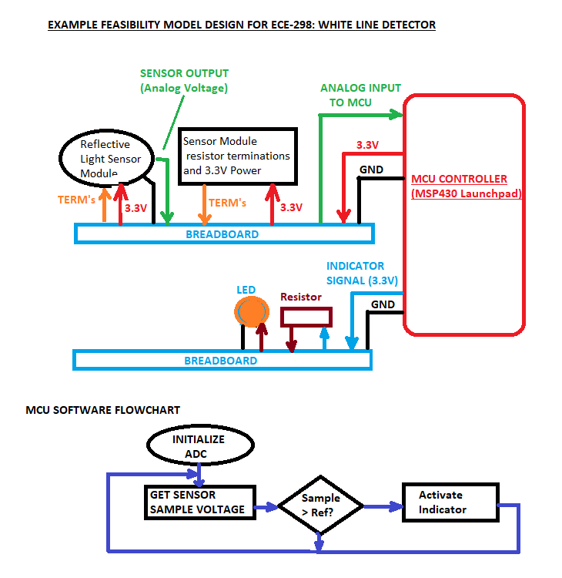

Figure 3: Simple Sketch of a Software Flowchart

## Initial Bill of Materials

* List what modules and components (including quantities) are needed from the ECE 298 Parts spreadsheet for your Feasibility Model Design